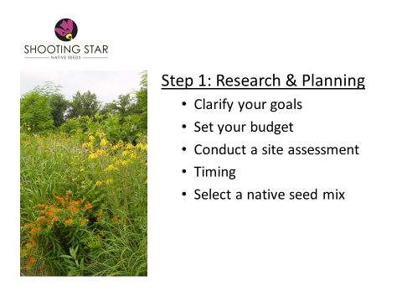
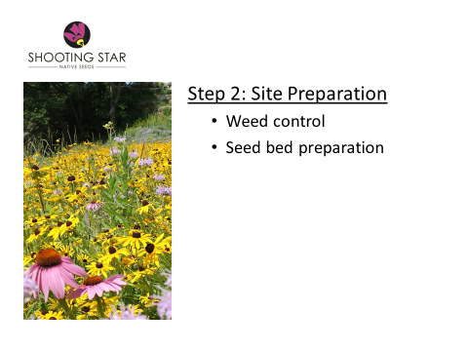
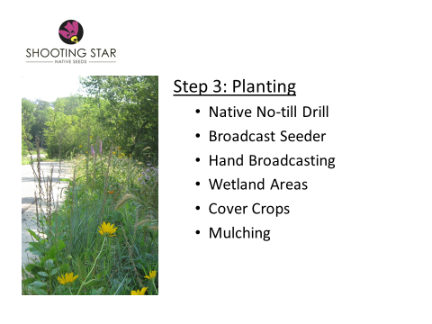
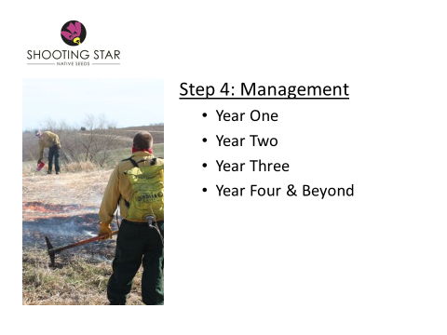
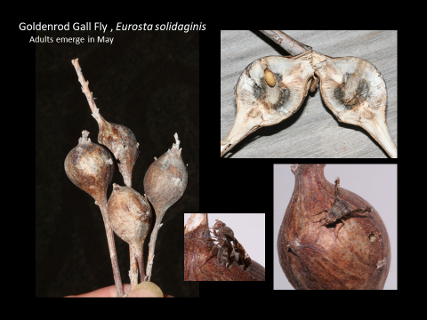
Prairie Smoke Annual Meeting
The Prairie Smoke annual meeting was held on March 6, 2022 at the Chatfield Public Library. Here is a brief summary of the meeting.
Announcements:
The Prairie Smoke website has been updated with a description of the fish hatchery tour. It is maintained, remotely, at no cost to Prairie Smoke.
Spring burn season is coming, and Barb Nigon is scheduling use of burn equipment. Contact her at prairiesmokeMN.org if you are considering a spring burn this year and need equipment or volunteers.
Walt Nigon is planning a time to maintain the burn equipment. Contact him at the address above if you want to help while learning about the equipment.
Potential field trips and activities: Watch the Events calendar or Prairie Smoke emails for details.
- A spring burn in the St. Charles area where members can observe or help
- A field trip to see the early stages of a prairie planting at Sargent’s North nursery
- View a restored trout streams in Whitewater Park
- Al Batt presentation about the benefits of prairie ecosystems for prairie birds
- Spring and Fall ditch cleanup
- Pocket prairie work day in Rochester
- Fall picnic

Election of Board members:
RuthAnn Yaeger resigned from the PS board after many years of service, and we acknowledged her many contributions to Prairie Smoke. We elected the following board members, including three new ones: Sue Wieseler, who volunteered to serve as secretary, Angela Smith, and Dave Vail. Our by-laws allow twelve board members.
Ed Pfannkoch (President)
Barb Nigon (Vice president)
Ryan Kemmerick (Treasurer and Membership coordinator)
Sue Wieseler (Secretary)
Susan Powers
Chuck Kernler
Angela Smith
Dave Vail

After the business was concluded, we enjoyed a delicious meal prepared by Barb Nigon.

Jessi Strinmoen from Shooting Star Native Seeds in Spring Grove MN was the featured speaker and gave an interesting presentation about the business of producing and selling native seeds, including the basic steps involved in planning, planting and maintaining a prairie. Jessi offered to arrange a tour of their facility for Prairie Smoke in the summer if we are interested.

MJ Hatfield, a Prairie Smoke member, prepared a short quiz on common prairie plant insects and how to find them. She encouraged PS members to look for and photograph insects and evidence of their presence on prairie plants which could make an interesting slide show in the future.

